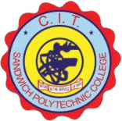
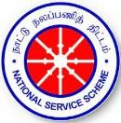
CIT SANDWICH POLYTECHNIC COLLEGE
(Government Aided Institution)
COIMBATORE– 641014
NATIONAL SERVICE SCHEME
REPORT ON REGULAR ACTIVITIES
The NSS unit I and unit II of 210-CITSPC conducted the following regular activities and other program during the period June 2024 – MAY 2025.

S.NO | DATE | NAME OF THE EVENT
1 | 12.06.2024 | Pledge on World Day against Child Labor
2 | 21.06.2024 | International Yoga Day Celebration
3 | 06.07.2024 | Community Initiatives – Emergency First Aid Training
4 | 29.07.2024 | Ek Ped Maa Ke Naam – Planting Tree Saplings
5 | 12.08.2024 | Drug Abuse Day - Pledge
6 | 15.08.2024 | Independence Day Celebration
7 | 24.09.2024 | NSS Day Celebration – Campus Cleaning & Swachhata Hi Seva - Pledge
8 | 15.10.2024 | Youth Awakening Day & World Students’ Day
9 | 23.12.2024 | Communal Harmony Week
10 | 13.01.2025 | Pongal Day Celebration
11 | 25.01.2025 | National Voters Day – Pledge
12 | 25.01.2025 | Seminar on impact of Drug on Mental Health & Health Camp
13 | 26.01.2025 | Republic Day Celebration
14 | 30.01.2025 | Pledge on Untouchability
15 | 31.01.2025 | National Road Safety – Human Chain & Rally
16 | 28.02.2025 | Drug Awareness Drama – “The Wrong Turn”
17 | 24.03.2025 | Drug Free TN App – Launching

1. Anti-Child Labour - Pledge
On June 12th, 2024, an oath-taking ceremony was held at CIT Sandwich Polytechnic College in observance of Anti-Child Labour Day. The event was organized by the NSS team, with approximately 150 students taking part in the ceremony. The theme of the oath taken during the event was to pledge commitment towards the eradication of child labour and to promote the protection, education, and well-being of children. Participants vowed to raise awareness, take action, and work towards creating a world where every child can live, learn, and grow in a safe and supportive environment free from exploitation.

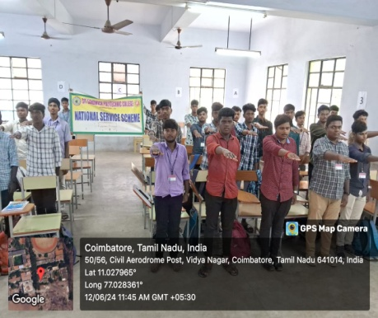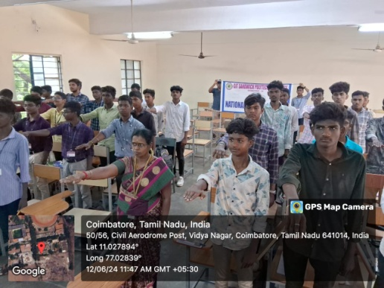

2. International Yoga Day Celebration
On June 21st, 2024, CIT Sandwich Polytechnic College hosted a Yoga Training Program to celebrate "International Yoga Day," which took place in the college conference hall. The event was attended by 110 second-year and third-year students, along with a few faculty members. The chief guests for the day were staff from the JSS Institute of Naturopathy and Yogic Sciences, Navakkarai, Coimbatore. The first chief guest, Dr. Ravikiren, a Professor from JSS Inys, gave an informative talk on the significance of "Yoga Day" and the importance of incorporating yoga into daily life. The second chief guest, Dr. V. Emi BNYS, Assistant Professor and Medical Officer, shared valuable tips on stress management and healthy eating habits. Following the lectures, Mr. Srinivasan, conducted a practical yoga session, teaching students various techniques, including meditation and Surya Namaskar poses. The students engaged enthusiastically in the session, gaining a deeper understanding of how yoga harmonizes the mind and body. The event provided students with an opportunity to experience the physical and mental benefits of yoga while learning its vital role in maintaining overall well-being.
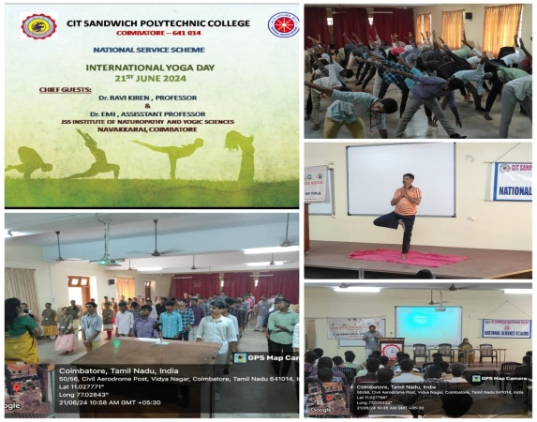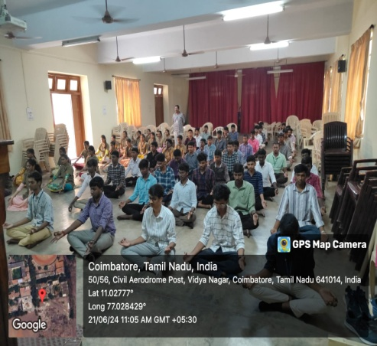

3. Community Initiatives – Emergency First Aid Training
As part of the induction program for first-year students, CIT Sandwich Polytechnic College organized a comprehensive Emergency First Aid Programme on 02.07.2024. The initiative, conducted by the NSS Units, was designed to equip students with essential life-saving skills and raise awareness about the importance of immediate medical assistance in emergency situations. The program was led by a team of qualified medical professionals and experts in first aid, who demonstrated a variety of emergency techniques. These included CPR (Cardiopulmonary Resuscitation), wound care, choking management, and how to respond to common injuries such as burns, fractures, and sprains. The experts also explained the importance of remaining calm and composed during emergencies and the role of bystanders in assisting the injured until professional help arrives. Students were actively engaged in practical demonstrations and hands-on training, where they practiced performing first aid techniques under the guidance of the medical team. This interactive approach ensured that all participants gained a clear understanding of how to respond effectively in an emergency.
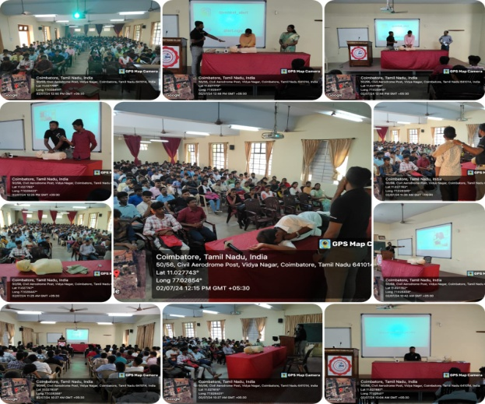
4. Ek Ped Maa Ke Naam – Planting Tree Saplings

The initiative "Ek Ped Maa Ke Naam" (One Tree in the Name of Mother) highlights the crucial role trees play in maintaining ecological balance and the well-being of our planet. Trees are not only essential for producing oxygen but also help in combating climate change, preventing soil erosion, and enhancing biodiversity. This initiative encourages people to honor the environment and show gratitude towards nature, symbolizing the nurturing qualities of a mother, which trees represent in their ability to sustain life. This event is conducted in CIT Sandwich Polytechnic College by NSS units. The staff members from CITSPC involved in the event.

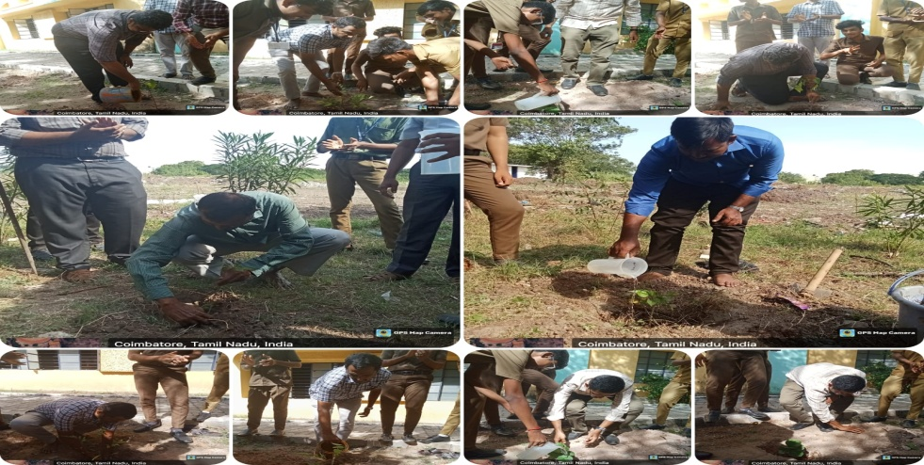

5. Drug Abuse Day – Pledge
On August 12th, 2024, a pledge against drug abuse was taken the students at CIT Sandwich Polytechnic College. The event saw the participation of 112 students, who solemnly vowed to stand against drug abuse and promote a healthy, drug-free lifestyle. The pledge served as a powerful reminder of the dangers of drug abuse, encouraging students to make informed decisions about their health and well-being. By participating in this event, students not only committed to avoiding drugs but also pledged to spread awareness about the harmful effects of substance abuse.
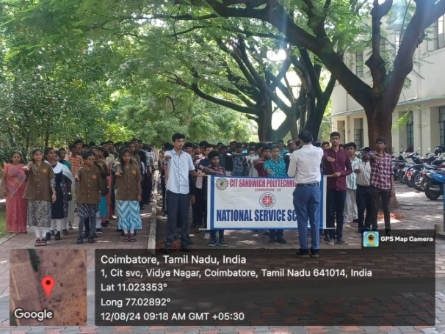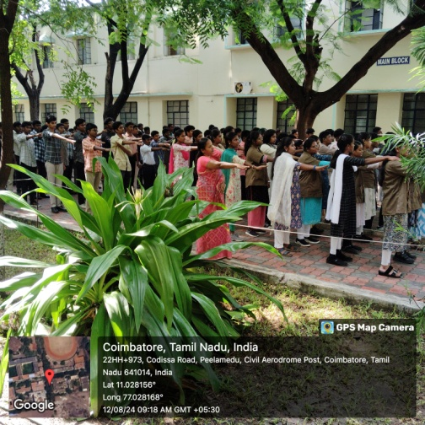
6. Independence Day Celebration

CIT Sandwich Polytechnic College celebrated Independence Day with great enthusiasm on August 15, 2024, organized by the NSS units. The event began with a vibrant march past by the NSS volunteers, showcasing their discipline and spirit. The flag hoisting ceremony was led by Principal Dr. R. Renuga, who delivered an inspiring speech highlighting the importance of independence and its relevance in the modern world. The event concluded with the distribution of sweets, bringing everyone together and strengthening the sense of unity and patriotism among all participants.

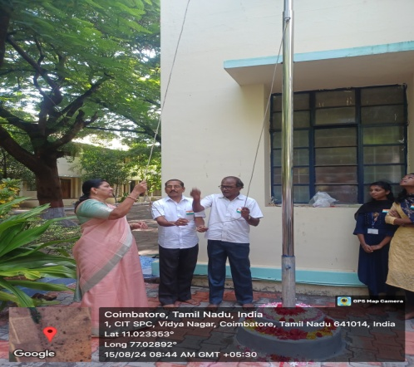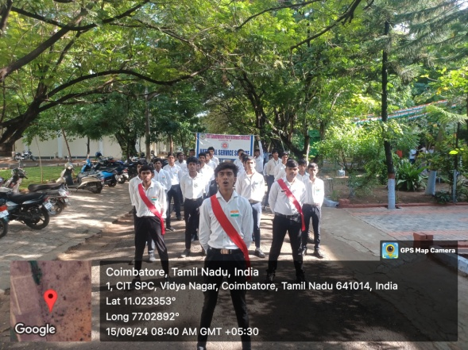

7. NSS Day Celebration – Campus Cleaning

On September 24, 2024, in celebration of National Service Scheme Day and as part of the Swachhata Hi Seva Program, the NSS units of CIT Sandwich Polytechnic College, Coimbatore, organized a cleaning activity on the college premises. The event saw active participation from 100 first-year NSS volunteers. In addition to the cleaning drive, the students took the Swachhata Hi Seva pledge, reinforcing their commitment to cleanliness and contributing to a healthier and more sustainable environment.

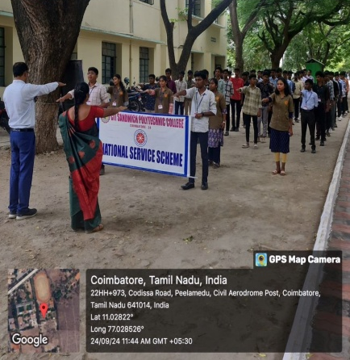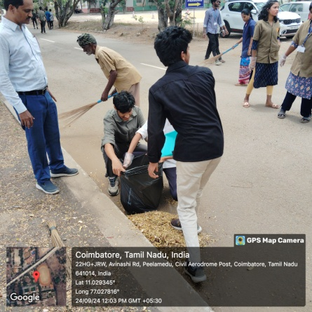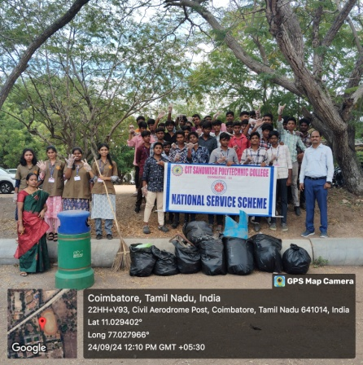

8. Youth Awakening Day & World Students’ Day

The NSS units of CIT Sandwich Polytechnic College celebrated Youth Awakening Day & World Students’ Day on Tuesday, October 15, 2024. The celebrations focused on remembering Dr.APJ Abdul Kalam. Events included an essay competition on “The People’s President – Dr.APJ Abdul Kalam” and a seminar on “Life Lessons and Leadership Qualities of Dr.APJ Abdul Kalam”. The venue was the Conference Hall, and 100 students participated in the seminar. In essay writing competition 25 students participated.

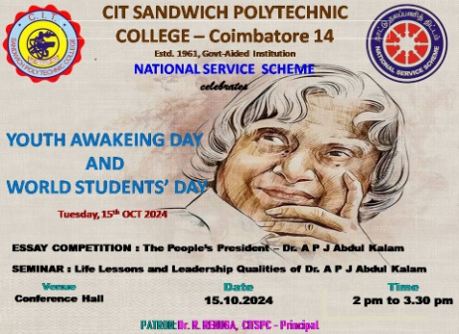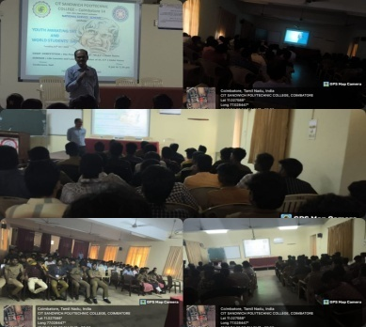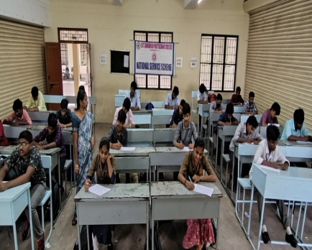

9. Communal Harmony Week

CIT Sandwich Polytechnic College through its NSS units organized a Communal Harmony event on 23rd December 2024, aiming to promote the importance of unity and mutual respect among students. The event was held at the CITSPC Conference Hall from 2:00 PM to 3:00 PM with 150 students. The program focused on the importance of interfaith harmony and understanding. The Chief Guest, Dr. Ganesh Muthuram, a Lecturer in English at the college, delivered a speech emphasizing the significance of tolerance, respect, and acceptance in a diverse society. The Communal Harmony event appears to be a commendable initiative aimed at fostering unity and mutual respect. By organizing such events, the college contributes to creating a more inclusive and harmonious environment for its students and the wider community.

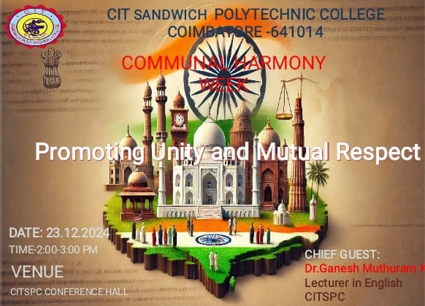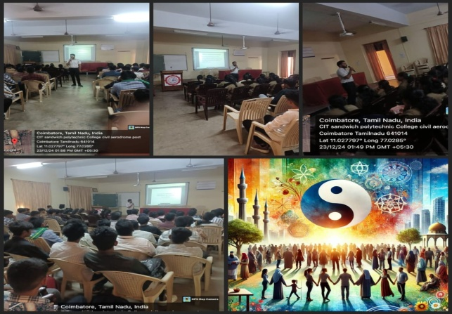

10. Pongal Day Celebration
The NSS Units at CIT Sandwich Polytechnic College organized an exuberant Pongal celebration on 13th January 2024. The event was graced by the esteemed presence of Dr. Renuga R, the Principal of the Institute, who was the chief guest for the occasion. The celebrations brought together faculty members, both teaching and non-teaching, along with the students, to honor the traditional festival of Tamil Nadu in grand style. The campus was meticulously cleaned and adorned for the occasion, setting a vibrant atmosphere for the festivities. The day began with a heartfelt invocation led by the NSS volunteers, filling the air with harmony and spiritual energy.
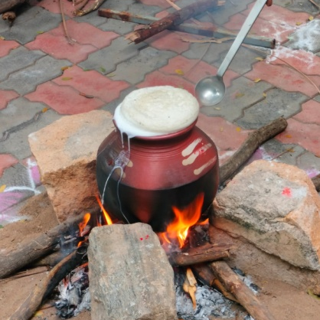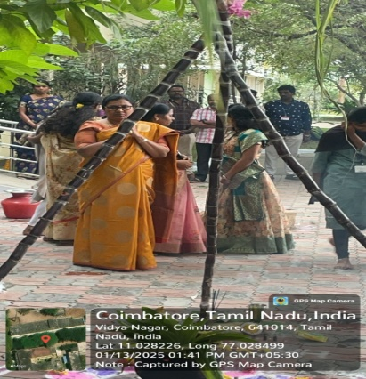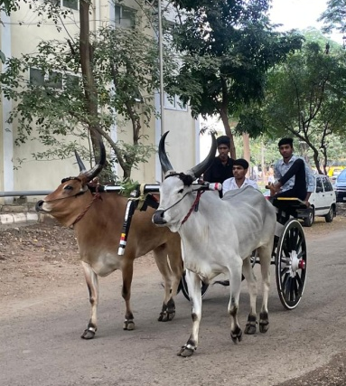
11. National Voters Day – Pledge
Voters' Day, observed on 25th January in CIT Sandwich Polytechnic College, holds significant importance in promoting awareness about the rights and duties of citizens in a democracy. The Voters' Day pledge taken in colleges serves as a vital reminder to students and faculty members about the power and responsibility of voting. The pledge taken not only encourages active participation in the democratic process but also instills the importance of responsible voting, creating well-informed and conscientious voters for a stronger democracy. 200 students have participated in the event.
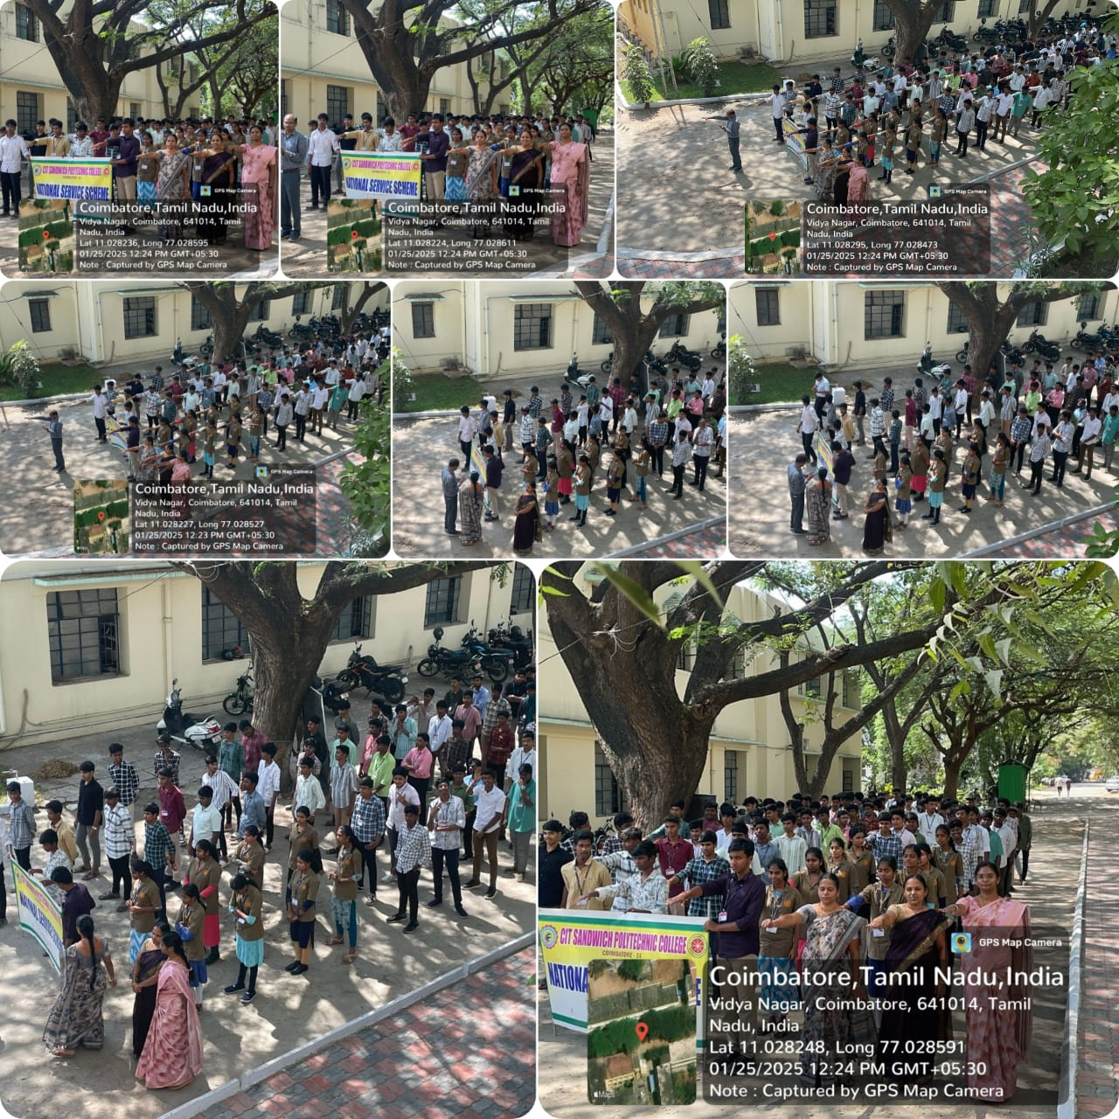
12. Seminar on impact of Drug on Mental Health & Health Camp
A seminar titled "Impact of Drugs on Mental Health" was conducted at CIT Sandwich Polytechnic College on January 25, 2023, organized by the Anti-Drug Committee in collaboration with the NSS Units. The seminar aimed to raise awareness about the detrimental effects of drug abuse on mental well-being and was attended by faculty members, 160 students, and health professionals.
The seminar began with a welcome address by the NSS Programme officer Dr.R.Rajajeyaganthan, who highlighted the growing concern of drug abuse among young people and its profound consequences on mental health. This was followed by an insightful presentation by the guest speaker, Dr. V. Emi BNYS, Assistant Professor and Medical Officer, who explained the direct relationship between drug abuse and mental health disorders.
Dr. Emi discussed various types of drugs, including narcotics, stimulants, and hallucinogens, and their impact on the brain and emotional state. She elaborated on how substance abuse leads to conditions such as anxiety, depression, psychosis, and even long-term cognitive impairments. Through her presentation, the audience gained a deeper understanding of the chemical and psychological changes drugs can induce, disrupting normal mental functioning and increasing the risk of mental illnesses. The seminar also included a segment on the role of the community and educational institutions in preventing drug abuse. The importance of creating a supportive environment for students and promoting mental health awareness was emphasized. Following the seminar a health camp is organized in the campus through which all students and staff members got benefited.

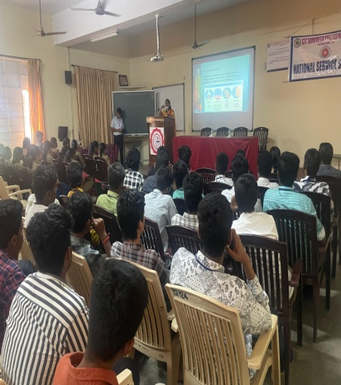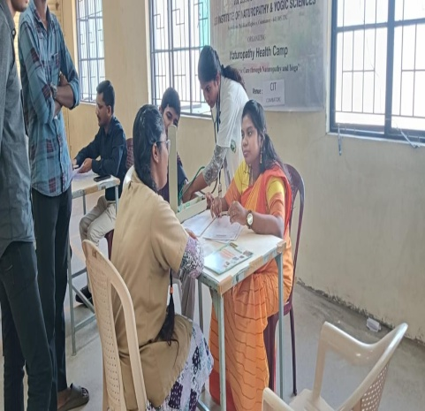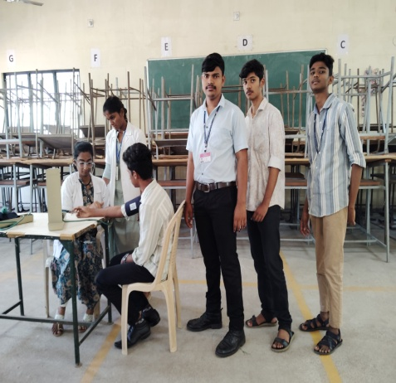

13. Republic Day Celebration
The NSS Units of CIT Sandwich Polytechnic College organized a grand Republic Day celebration on 26th January 2025, marking the day when the Constitution of India came into force. The college campus was beautifully adorned with flags and vibrant flowers to set the tone for the occasion. The celebration began promptly at 8.30 a.m., with all students and faculty members gathering in the college premises. The event kicked off with a patriotic March-past by the students, paying tribute to the nation, "INDIA." In front of a joyous and enthusiastic crowd, the Principal Dr.R.Renuga of the college hoisted the National Flag, and the assembly stood in reverence as the National Anthem was sung. In her address, the Principal shared motivating words, emphasizing the importance of sacrifice, hard work, honesty, and character development as essential values for students to uphold. The students took center stage with melodious patriotic songs and heartfelt speeches, further enhancing the spirit of the day. The event concluded with a gesture of goodwill, as sweets and chocolates were distributed to everyone present, bringing a sweet end to the celebration. Overall, the Republic Day celebration was a heartwarming and inspiring event that brought together the entire college community to honor the values of the nation.
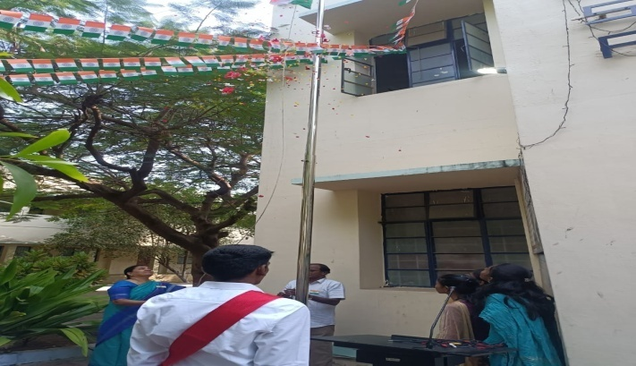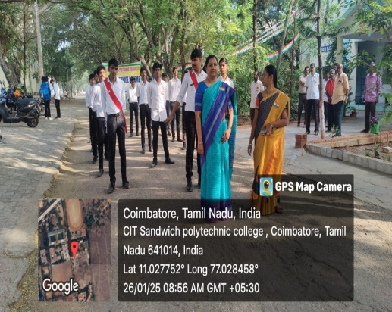

14. Pledge on Untouchability
On 30th January 2025, the NSS units of CIT Sandwich Polytechnic College organized an event to observe the Untouchability Pledge as part of its ongoing commitment to promoting equality and social justice. The event aimed to raise awareness about the harmful effects of Untouchability and to encourage students and faculty members to contribute towards building a society based on respect, dignity, and equality for all. The pledge urged everyone to treat all individuals with equality and dignity, irrespective of their caste, religion, or background. 180 students have taken the pledge.
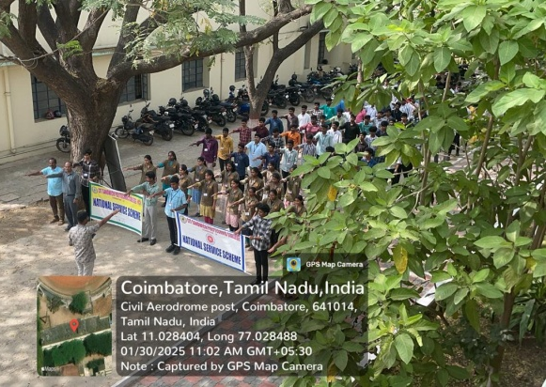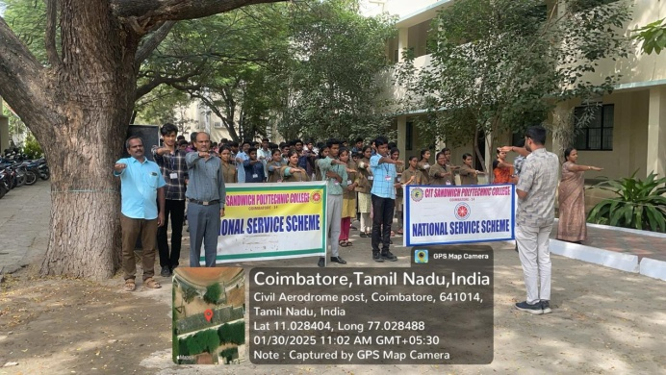

15. National Road Safety – Human Chain & Rally
In observance of Road Safety Month, the students of CIT Sandwich Polytechnic College, organized through the NSS Units, held a Rally and Human Chain event on 31st January 2025. The initiative aimed to raise awareness about the importance of road safety and educate the public on adhering to traffic signals and safety measures. The event began with a rally, where 60 students, adorned with helmets and carrying banners and placards, took to the streets. The students displayed powerful messages on the importance of wearing helmets, obeying traffic signals, and following safe driving practices. The banners and placards served as visible reminders to drivers and pedestrians alike, emphasizing the need for caution on the roads.
Following the rally, a human chain was formed by the students on the main roads near the college, further spreading the message of road safety. This creative initiative helped draw attention to the cause and encouraged the community to take safety precautions seriously. By utilizing banners, placards, and helmets, the students effectively communicated key safety tips to the public, fostering a collective responsibility for safer roads. The event not only raised awareness but also highlighted the active role the students of the college play in promoting public health and safety. This rally and human chain event proved to be an impactful and memorable part of Road Safety Month, reinforcing the critical need for everyone to prioritize safety on the roads.
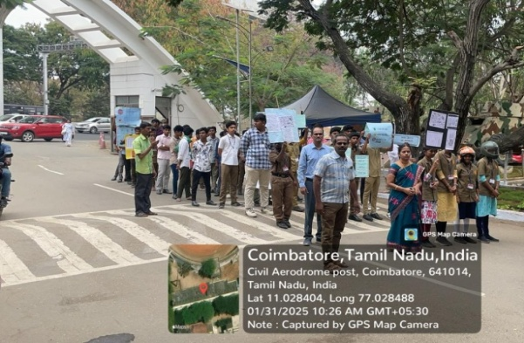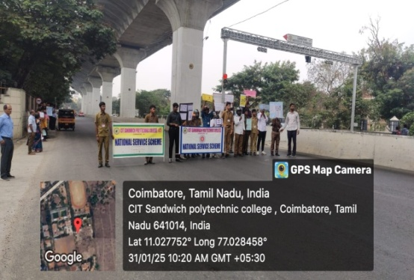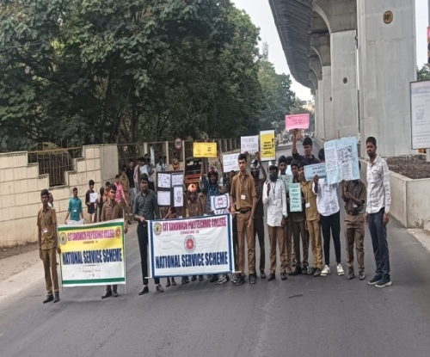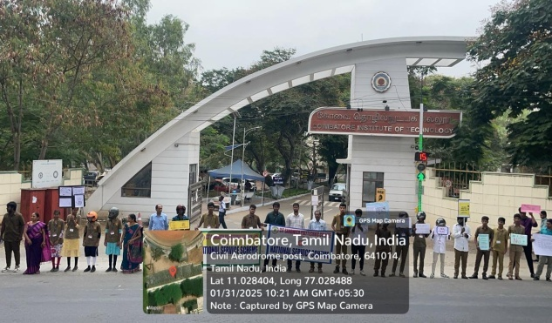
16. Drug Awareness Drama – “The Wrong Turn”
The Anti-Drug Committee, in collaboration with the National Service Scheme (NSS), organized a thought-provoking drama event titled “The Wrong Turn” on 28th February 2025. The drama, scripted and performed by the first-year DME students of CITSPC, aimed to raise awareness about the dangers of drug abuse. Through powerful performances and a compelling storyline, the students effectively conveyed the harsh realities and consequences of drug addiction. The event served as a strong reminder to stay away from harmful substances and make the right choices in life. The initiative was well-received and significantly contributed to spreading drug awareness among the student community.

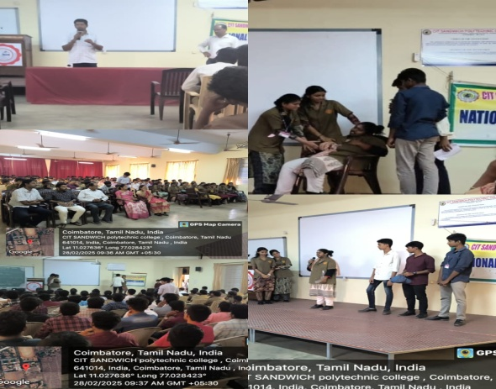
17. DRUG FREE TN App – LAUNCHING
The Anti-Drug Committee, in collaboration with the National Service Scheme (NSS), conducted DRUG FREE TN app launch event on 24th March 2025. The importance and uses of the app were explained to the student community. The procedure to use the app effectively was also demonstrated to the students. All the students were advised to install app in their mobiles and instructed to create awareness about this app to public. All students got benefited by this program.

